Game Systems, Balance, and Player Experience

Introduction
In the previous class, you designed and played your own games. During that process, you likely encountered problems such as confusion in rules, imbalance between players, or lack of engagement.
This lecture focuses on understanding how to design games that are clear, balanced, engaging, and enjoyable for players.

1. Core Elements of a Game

Clear Goal (Win/Lose Condition)
Every game must have a clear objective. Players should always understand what they are trying to achieve.
Without a defined win or lose condition, a game lacks direction and purpose. A clear goal provides motivation and structure to the player’s actions.
Examples:
- Eliminating all opponents
- Reaching a target score
- Collecting the most items
A well-designed game ensures that the player always knows how they are progressing toward victory.

Rules
Rules define what actions are allowed and how the game operates.
If a game has too many rules, it becomes confusing. If it has too few, it becomes shallow and uninteresting.
Good rules are:
- Simple to understand
- Consistent
- Meaningful
A strong design allows a new player to quickly understand how to play.

Player Interaction
Interaction between players is essential for engagement.
Types of interaction include:
- Direct interaction (attacking, stealing, blocking)
- Indirect interaction (competing for resources, bidding)
Games where players cannot influence each other often feel isolated and less engaging.

Feedback
Feedback is how the game communicates with the player.
Every action should produce a clear response:
- Visual (animations, effects)
- Audio (sounds, cues)
- System (score changes, outcomes)
Without feedback, players feel disconnected from the game and cannot understand the results of their actions.



2. Risk vs Reward
A fundamental principle of game design is balancing risk and reward.
- Risk is the possibility of failure or loss
- Reward is the benefit gained from success
Meaningful decisions occur when players must choose between safe and risky options.
Examples:
- Spending more resources to increase chances of winning
- Using a powerful ability that may fail
- Taking a gamble for a higher reward
If there is no risk, the game becomes predictable and boring. If risk is too high with little reward, the game becomes frustrating.
A well-balanced game allows players to control how much risk they want to take.

DeadCells Loot Chest

3. Clarity and Simplicity
Clarity is one of the most important aspects of good design.
If players are confused, the design has failed.
Common issues include:
- Unclear rules
- Too many mechanics
- Poor explanation of systems
Good design ensures that:
- Rules are easy to follow
- Actions are understandable
- Outcomes are predictable and fair
A game should be easy to learn, even if it is difficult to master.

4. Fun and Player Experience
Fun is not random; it is designed.
A good player experience includes:

Appropriate Length
Games should not feel unnecessarily long. Players should remain engaged throughout.

Avoiding Frustration
Challenge is important, but frustration occurs when players feel powerless or confused.

Forgiving vs Punishing Design
- Punishing design: small mistakes lead to major consequences
- Forgiving design: allows small errors without severe penalties
Forgiving systems improve player experience by reducing unnecessary frustration.

Examples of Forgiveness

Coyote Time
Allows the player to still jump for a brief moment after leaving a platform.

Celeste Cayote Jump

Forgiving Hitboxes
Actions register even if the player is slightly inaccurate.
These systems make games feel responsive and fair without reducing challenge.

5. Learning and Difficulty
Games should teach players gradually.

Learning Zones
There are three states:
- Too easy → boredom
- Too difficult → frustration
- Balanced challenge → engagement
The goal is to keep players in the balanced zone.

Difficulty Curves
Games should follow a progression:
- Start simple
- Introduce mechanics gradually
- Increase complexity over time
Players should learn through gameplay rather than long explanations.

6. Game Economy
Game economy refers to how resources are earned and spent.

Key Concepts
- Source: how players gain resources
- Sink: how players spend resources
Examples include money, points, health, or items.

Balancing Economy
- Too many resources → no challenge
- Too few resources → frustration
A balanced economy ensures meaningful decisions about spending and saving.

7. Retention
Retention refers to keeping players engaged over time.
Players return to a game when:
- They are having fun
- They feel progress
- They have goals to achieve
Systems that support retention include:
- Rewards
- Progression systems
- Unlockable content
However, forcing players to return through pressure or punishment often leads to negative experiences.

8. Prototyping
Prototyping is the process of quickly creating a simple version of a game.

Greyboxing
Greyboxing focuses on structure and gameplay rather than visuals.
Examples:
- Paper prototypes
- Simple shapes and layouts
The purpose is to test ideas quickly and identify problems early.
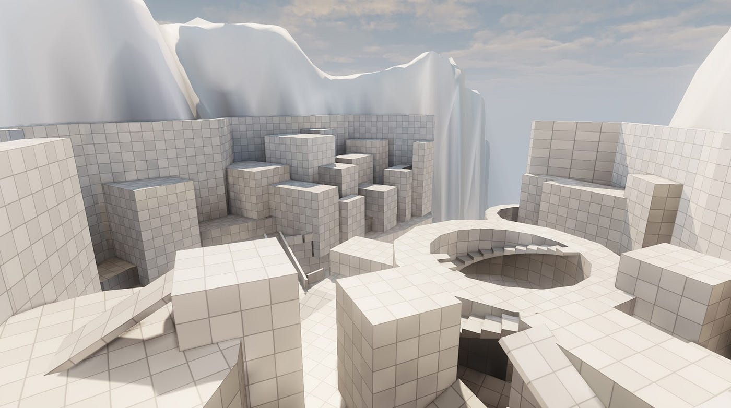
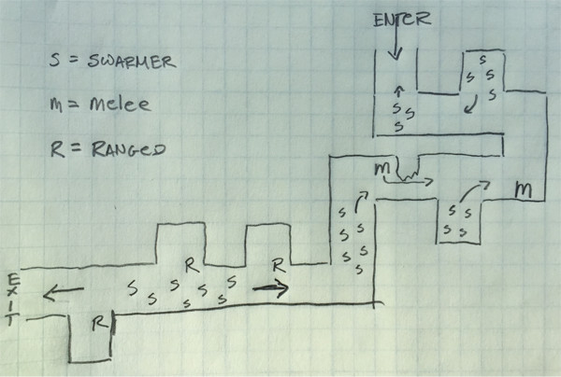

Key Principle
Focus on gameplay first, not visuals.

9. Playtesting
Playtesting is essential in game design.
Designers must observe how real players interact with the game.

What to Look For
- Confusion in rules
- Balance issues
- Player engagement
- Unintended strategies

Important Approach
- Observe without interfering
- Let players make mistakes
- Identify where design fails
If players struggle, it is usually a design problem, not a player problem.

Conclusion
A well-designed game:
- Has clear goals and rules
- Provides meaningful choices
- Balances risk and reward
- Is easy to understand
- Avoids unnecessary frustration
- Teaches players gradually
- Uses balanced systems
- Is tested and improved through playtesting
Game design is an iterative process. The first version is rarely perfect. Improvement comes through testing, feedback, and refinement.

